Kenneth Fisher

WEB 125.0001

Final Project

04/25/22

Concept Document.

Part 1:

Website Name: Welcome to Woodpine, A Companion Site.

Website URL: <https://wcet.waketech.edu/Kmfisher/WEB125/project/index.html>

Target Market: Ages 16+, Readers of Fiction novels, including but not limited to: Fantasy/Sci-Fi fictions. The novels feature elements of both.

What it Does / How it Works: The page provides a brief synopsis of the Town of Woodpine. It allows for a reader new to the series a place to familiarize themselves with the important characters/locations of the books. It would also serve as a reference to those who are returning to the series, or simply came across a name/location that they need a refresher on.

Major Features: Themed pages including a character image gallery, synopsis of major locations including key individuals and events at those locations. These pages provide a character image / location images to help the reader cement an idea of the character/place in their minds. A history page to provide a place to cover backstory, with a table to provide synopsis of events in a time line fashion. The table entries are linked with anchor tags to jump you to the details of the event provided below.

Sitemap:

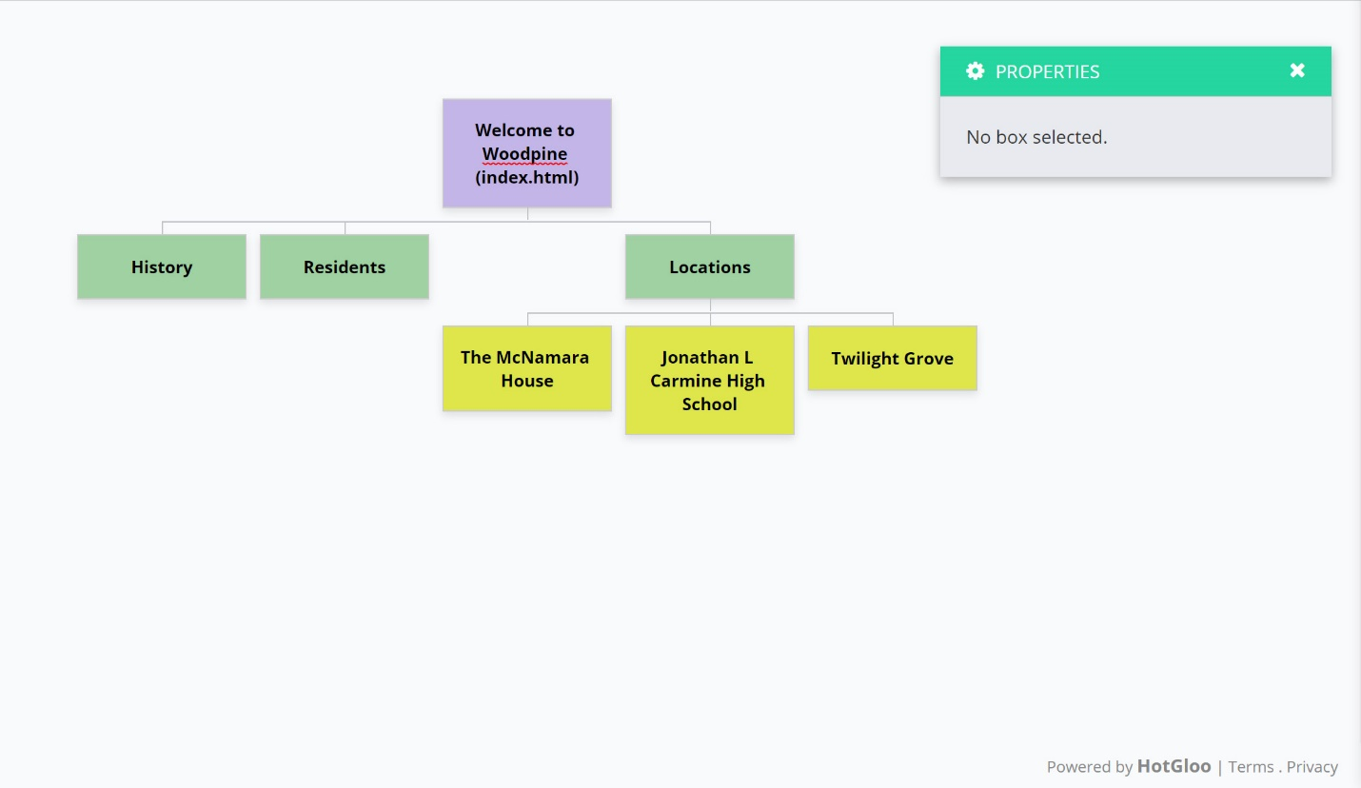

Design Choices:

I chose to go with a bootstrap layout as it seemed to offer a more professional and clean set up. I wanted to provide visuals for the reader to key in on, especially since this is a work of fiction, and as they say, a picture is worth 1000 words.

The header changes from a visual of the town and general area, to visuals of the Carmine House and School on their respective pages. This is to further stress the importance of these locations, as well as provide a visual of the intended ‘look’ and feel of the location. We are not trying to supplant the mental images created through reading, but to enhance them with images that provide feeling or subtext. The Twight Grove image, for instance, has a feature of light through the trees, to attempt to explain the mystical quality about the place. The McNamara House header, shows an old, mansion façade with tiled roof and wrought iron detailing surrounding windows and some intricate stonework. This is to provide both a feeling of wealth, but as well as age and established authority.

The white backgrounds used in the main portions of the site are to keep the background non-intrusive, while the gray of the navbar Is designed for contrast. Text was kept black for simplicity sake.

The History page features a table of indexed entries that link to sections on the page that tell about the event. This is achieved through anchor tags, to jump the visitor down to the correct section of the history, allowing for easy access of particular information. This will become more beneficial as the page grows longer with subsequent additions.

One addition I did not get to add, but would in the event of a working page are character pages connected to the character images and links in the footer. In a full site, each character shown in the character gallery would have a page linked to their picture and name, that connected to a biography page. That same page would be readily accessible through the footer for characters mentioned there.

Lastly, the page footer would connect to social media sites pertaining to either the author of the series or any series documentation / pages on those sites. The footer, I believe, provides a professional cap to the site as a whole. IT is the same gray as the navbar, to add a sense of oneness. The copyright is a tad darker than the other parts of the header/footer to have it stand out a little.

Part 2: Competitive Analysis

<http://theroadtocharacter.com/>

The Road to Character, by David Brooks. The book’s site looks old. It does appear to be responsive but at a large viewport, the images and videos look stretched and lose some of their quality. The site is a single page site, with ill defined sections. (for instance, the blog section isn’t titled. You wouldn’t know it was a blog except for the older posts link after the 3rd article.

I believe that my site has improved styles and site organization over the page provided. Multiple pages breaks the page into easily located chunks of information. The Road to Character uses few images, and has a lot of empty white space. My site uses many images to provide visual representations. The Road to Character site does include video files, which my site does not; however, my site is a fantasy/fiction site, where the Road to Character is a site from a well established author who has enough popularity and backing to have been invited on Oprah. As well, the Road to Character is a non-fiction book.

Part 3: Information Architecture

((See sitemap shown above))